**Week 04 Team Activity: Foundation Programs Design**

**Student Name:** OKORO

**Course:** CSE 210 – Programming with Classes **Date:** October 1, 2025

**Foundation Program #1: Abstraction with YouTube Videos**

The program stores information about YouTube videos and their comments. It uses classes to abstract the details of videos and comments.

**Classes and Responsibilities**

**1. Comment**

* **Attributes:**

1. commenterName: string
2. text: string

* **Methods:**

1. Constructor to set name and text
2. Getters (optional if needed)

**2. Video**

* **Attributes:**
  1. title: string
  2. author: string
  3. lengthInSeconds: int
  4. comments: List<Comment>
* **Methods:**
  1. Constructor to set title, author, and length
  2. AddComment(comment: Comment)
  3. GetCommentCount(): int
  4. GetComments(): List<Comment>

**3. Class Diagram**

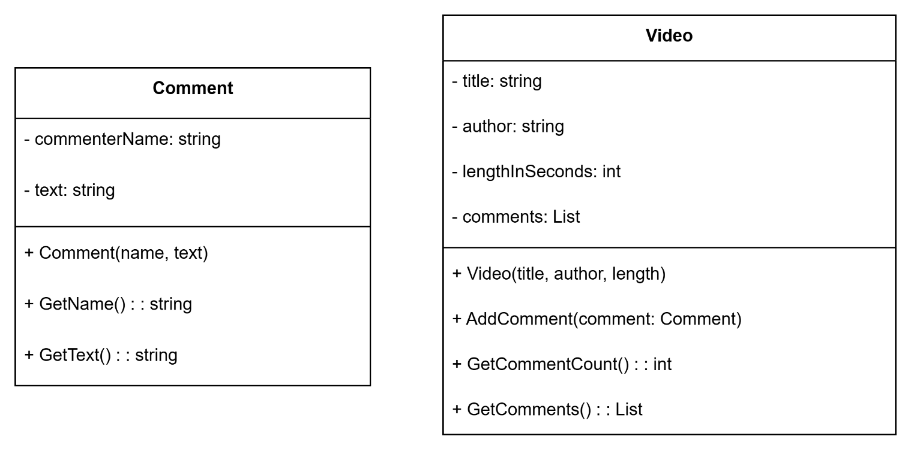

**Program Flow Description**

1. Create 3–4 Video objects.
2. Add 3–4 Comment objects to each video.
3. Store all videos in a list.
4. Loop through the list:
   1. Display video title, author, length, and number of comments.
   2. Display each comment under the video.

**Foundation Program #2: Encapsulation with Online Ordering**

The program manages customer orders, calculates total prices, and generates packing and shipping labels using encapsulated classes.

**Classes and Responsibilities**

**1. Address**

* **Attributes:**
  1. street: string
  2. city: string
  3. state: string
  4. country: string
* **Methods:**
  1. Constructor to set all fields
  2. IsInUSA(): bool
  3. GetFullAddress(): string

**2. Customer**

* **Attributes:**
  1. name: string
  2. address: Address
* **Methods:**
  1. Constructor to set name and address
  2. LivesInUSA(): bool
  3. GetName(): string
  4. GetAddressString(): string

**3. Product**

* **Attributes:**
  1. name: string
  2. productId: string
  3. price: double
  4. quantity: int
* **Methods:**
  1. Constructor to set all fields
  2. GetTotalCost(): double
  3. GetPackingInfo(): string

**4. Order**

* **Attributes:**
  1. products: List<Product>
  2. customer: Customer
* **Methods:**
  1. Constructor to set customer
  2. AddProduct(product: Product)
  3. GetTotalPrice(): double
  4. GetPackingLabel(): string
  5. GetShippingLabel(): string

**Class Diagram**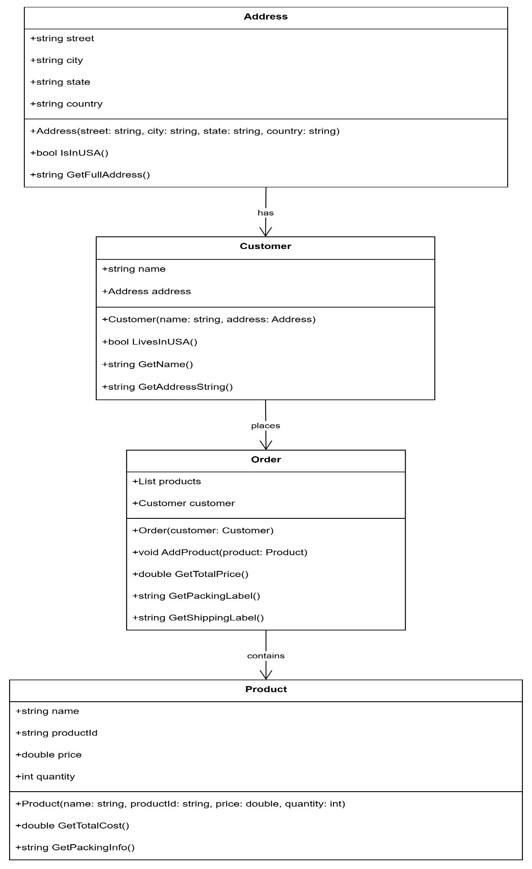

**Program Flow Description**

1. Create two Customer objects with different Address values.
2. Create two Order objects, each linked to a customer.
3. Add 2–3 Product objects to each order.
4. For each order:
   1. Display packing label (product name and ID).
   2. Display shipping label (customer name and address).
   3. Display total price (including shipping).